AWS Cost Management Instructions
Follow this procedure to create an AWS usage budget that will alert you via email if your consumption of compute and storage services (including EMR) exceeds some monthly maximum cost that you can set. This is one way to protect yourself from being surprised by a high monthly bill if you forget to terminate use of some AWS resources.
To create a usage budget with alerts on high use
- Sign in to the AWS Management Console and enter “billing and cost management” into the search box at the top of the page and then select Billing and Cost Management from the Services list

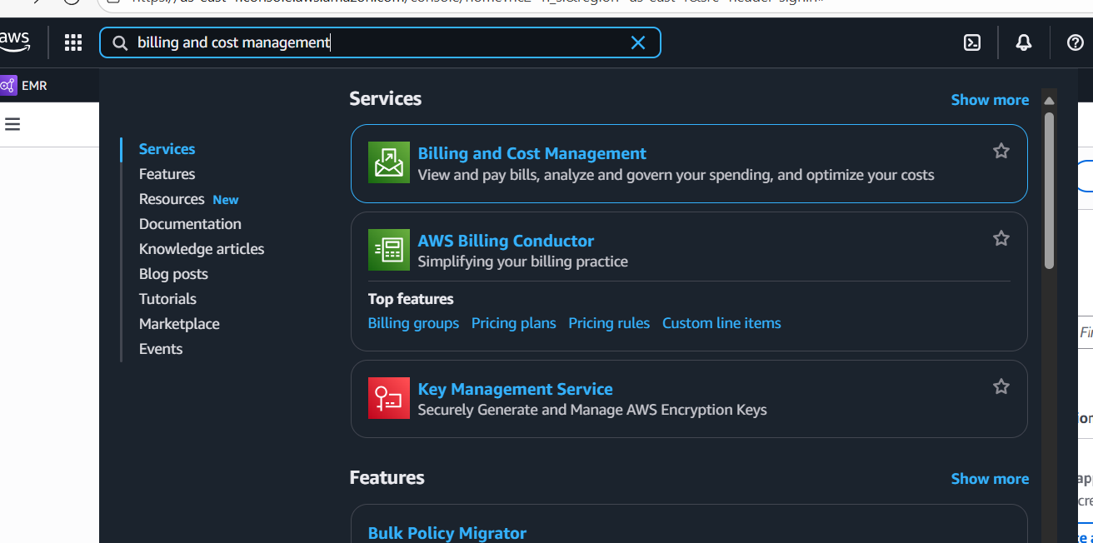

- In the Billing and Cost Management navigation pane, choose Budgets

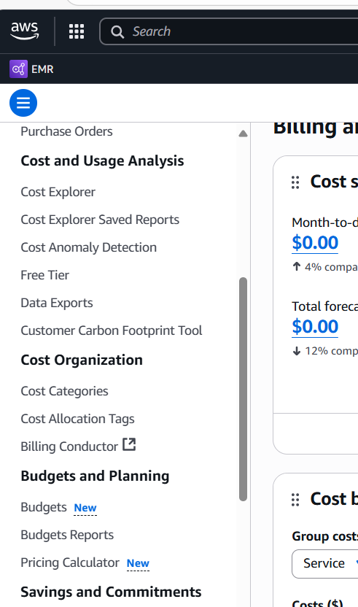

- At the top right of the next page, choose Create budget.

- At the next page, for Choose budget type (see below)
  - Accept the default) Use a template (simplified)
  - Then, select Monthly cost budget.

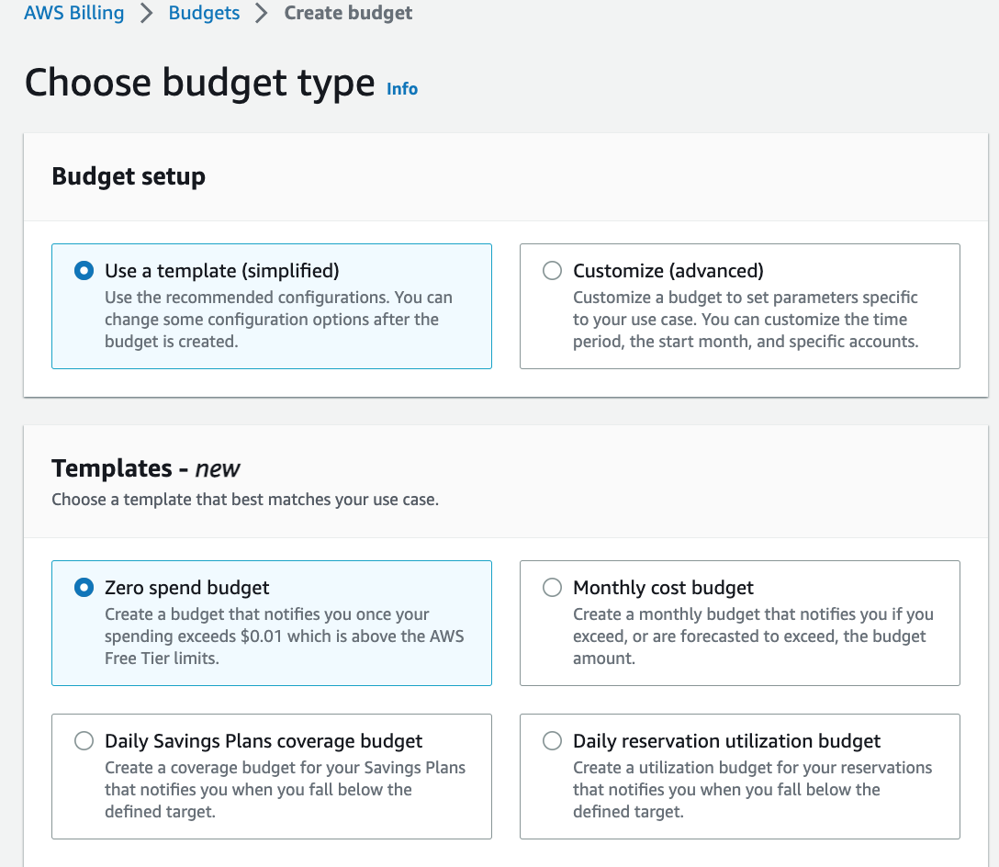

- Now scroll down to the Monthly cost budget – Template section
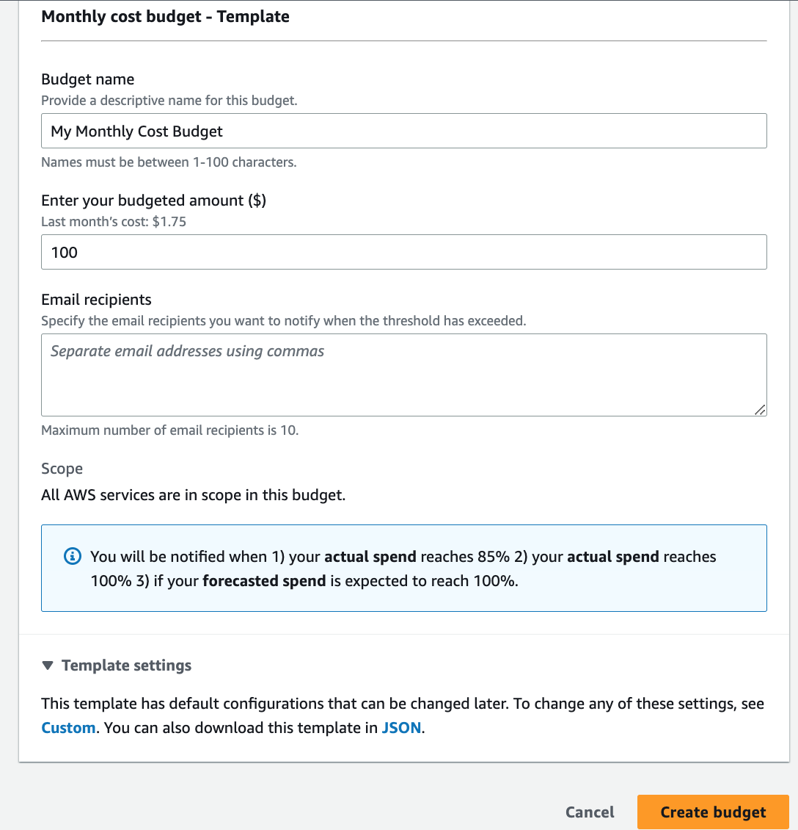
  - Under Enter your budget amount enter the total amount you expect to spend each month, use something like $25.
  - Specify your email address into the “Email recipients” box
  - Select “Create budget”

Now you should see something like this, and you are done!

